**

CMPE 287 - Software Quality Assurance and Testing

**Fall - 2014**

**Project – Testing Instagram mobile application**



**Instructor:**

Dr. Jerry Gao

**AUTOMATION TEST REPORT**

**Submission Date: 12/08/2014**

**Submitted by:**

Team - Session1- Group 6

Divanshu Arneja - SJSU ID: 009437064

Piyush Seth - SJSU ID: 009425247

Saumil Jain - SJSU ID: 009428419

Shilpa - SJSU ID: 009392513

Surbhi Rautji - SJSU ID: 009317555

Table of Contents

**1.** **Introduction** 5

1.1. Automation testing focus and objectives 5

1.2. Document Structure 6

1.3. Scope 6

**2.** **Overview of testing tools used -** 7

2.1. Perfecto Mobile– 7

2.2. Neoload – 7

**3.** **Performance test cases and data –** 8

3.1. Test cases for stress testing - 8

3.2. Test data for stress testing - 9

3.3. Test results for stress testing - 10

3.4. Test cases for load testing - 10

3.5. Test data for load testing - 19

3.6. Test results for load testing - 19

**4.** **Automation functional Test scripts–** 20

4.1. Automated test scripts- 20

4.1.1. Automated test scripts for IOS - 20

4.1.2. Automated test scripts for Android - 25

4.2. Summary of test results - 29

4.2.1. Summary of test results for IOS - 29

4.2.2. Summary of test results for Android - 30

**5.** **Automation Test results and Summary–** 30

5.1. Scripts for IOS - 30

5.2. Scripts for Android- 35

5.3. Functionality results - 40

5.4. Automation Summary- 48

**6.** **Automation test cost and complexity -** 48

6.1. Automation Test Cost – 48

6.1.1. Infrastructure Cost 48

6.1.2. Tool Cost 49

6.1.3. Human Resource Cost 49

6.2. Test results analysis – 50

**7.** **Automation test coverage –** 51

**8.** **Comparison between automated test cost and manual test cost –** 52

**9.** **Summary -** 53

**10.** **References** 53

**Version History**

|  |  |  |
| --- | --- | --- |
| **Date** | **Version** | **Description** |
| 12/02/14 | Automation Report 1.0 | Initial Draft. |
| 12/04/14 | Automation Report 1.1 | Inserted more Statistical Reports. |
| 12/08/14 | Automation Report 1.2 | Final Draft. |

## **Introduction**

In the era of growing technology, it is very important to maintain the quality of product developed. Every software company dreams that whenever they release a product in market, it should be defect free. Companies spend thousands of dollars in complete life cycle of a software product starting from the development to live in production. At every stage of its life cycle, software is tested rigorously, yet ended with defects. Software Testing is the other name for the quality of the product. The better the coverage of all the scenarios of a product the best quality it has. Thus, test engineers are always under pressure to achieve maximum test coverage of software.

Automating the testing procedure helps test engineers to achieve maximum test coverage in limited time and formalize the testing process. Automation reduces effort and time for testing a product over manual testing. But again we cannot automate everything while testing so manual testing has its own importance in a way.

With automation of testing process the goal should be reducing manual testing hours, number of test cases, and test data with assurance of maximum test coverage. Automation helps in testing of large and complex software, subsiding the chance of error by manual testing.

## Automation testing focus and objectives

The major goal of automation is to reduce the cost and complexity of the testing procedure when compared to the manual testing. It should be efficient, reliable, enhancing the testing process and producing correct results. Moreover the testing scripts should be re-useable, can be used across the different platforms and environments. Test scripts once written should be re-used with upcoming release of the product.

A level of consistency should be maintained which should be greater than that can be achieved with manual testing. Automated testing scripts should have minimal dependency on human.

We are trying to cover following features of Instagram application with automation testing.

* GUI Feature
* Sign Up Feature
* Location based Features
* Environment and Platform

The testing tools we are using to automate testing of our application Instagram are:

* Perfecto Mobile
* NeoLoad

Perfecto Mobile is used for automating testing of GUI features, Sign Up, Location and Environment and Platform.

NeoLoad is used for automating performance, Load and Stress testing of Instagram application.

## Document Structure

Our document structure comprises of the following:

1. Performance testing and results: This section covers the performance testing and its results. This is done by using **Neoload**.
2. Automation testing and results: This section covers the automation testing and its results. This is done by using **Perfectomobile.**
3. Cost: Cost of testing.
4. Summary: Summary of all the testing stats using charts and graphs.

## Scope

The scope of the document is to cover all the automation for all the different components of Instagram. It also tells us about the performance of the application in various environments.

## **Overview of testing tools used -**

## Perfecto Mobile–

Perfecto Mobile is a cloud based automation testing tool used for testing mobile and web application. It provides testing of various different devices running on different operating system.

We can create scripts and run them on the real devices on the real network.

It is secure, easy to learn and provides simple UI for automation.

## Neoload –

NeoLoad is a tool for performance testing of mobile applications. The tool is helpful to developers and testers to increase the performance of the application. By using NeoLoad, we can simulate the traffic up to millions of users such that we are able to test the application performance under heavy load.

We have used NeoLoad for performance, stress and load testing. NeoLoad can be used for testing the native mobile application. Follow below steps to set up Instagram a native mobile application with NeoLoad for load testing.

Steps -

* Download and Install NeoLoad for windows.
* Select the search criteria and data to be recorded.
* Modify and submit

Creating Test Cases in NeoLoad -

* Click start button to record steps.
* A virtual user will start recording the feature.
* Browser setting can also be provided and assign HTTP traffic or Adobe RMTP traffic

## **Performance test cases and data –**

## Test cases for stress testing -

|  |  |
| --- | --- |
| Test Case ID: ST-1 | Test Item: Instagram Native Mobile App |
| Tested by: Surbhi Rautji | Document Date: 12/1/2014 |
| Test Type: Stress Testing | Test Suite: ST_1.1 |
| Product Name: Instagram Mobile App | Release and Version No: V 6.1.4 |
| Test Case Description: To test whether the Instagram Mobile native app works properly when the automated test scenario are run in a loop for one times | |
| Specifications: | |
| Operation Procedure:  Install the Instagram app in the mobile device.  Connect to Neoload- node | |
| Pre-conditions: Start the automated test script for feature List. | Post-conditions: To validate the features of Instagram native mobile app. |
| Input data and/ or events: The data feed is given automatically through the test script. | Expected Output data and/ or events: The one scenario feature perform their functions properly for 5 seconds. |
| Required Test Scripts: IN-ST_1 | |

|  |  |
| --- | --- |
| Test Case ID: ST-2 | Test Item: Instagram Native Mobile App |
| Tested by: Surbhi Rautji | Document Date: 12/1/2014 |
| Test Type: Stress Testing | Test Suite: ST_1.1 |
| Product Name: Instagram Mobile App | Release and Version No: V 6.1.4 |
| Test Case Description: To test whether the Instagram Mobile native app works properly when the automated test scenario are run in a loop for ten times | |
| Specifications: | |
| Operation Procedure:  Install the Instagram app in the mobile device.  Connect to Neoload- node | |
| Pre-conditions: Start the automated test script for feature List. | Post-conditions: To validate the features of Instagram native mobile app. |
| Input data and/ or events: The data feed is given automatically through the test script. | Expected Output data and/ or events: The one scenario feature perform their functions properly for 5 seconds. |
| Required Test Scripts: IN-ST_2 | |

|  |  |
| --- | --- |
| Test Case ID: ST-3 | Test Item: Instagram Native Mobile App |
| Tested by: Surbhi Rautji | Document Date: 12/1/2014 |
| Test Type: Stress Testing | Test Suite: ST_1.1 |
| Product Name: Instagram Mobile App | Release and Version No: V 6.1.4 |
| Test Case Description: To test whether the Instagram Mobile native app works properly when the automated test scenario are run in a loop for hundred times | |
| Specifications: | |
| Operation Procedure:  Install the Instagram app in the mobile device.  Connect to Neoload- node | |
| Pre-conditions: Start the automated test script for feature List. | Post-conditions: To validate the features of Instagram native mobile app. |
| Input data and/ or events: The data feed is given automatically through the test script. | Expected Output data and/ or events: The one scenario feature perform their functions properly for 4 seconds. |
| Required Test Scripts: IN-ST_3 | |

## Test data for stress testing -

The below table has been designed to note down the time of execution of the each features when run with the automated test scripts. All the time is noted in seconds.

|  |  |  |  |
| --- | --- | --- | --- |
| **Features** | **Loop Count 1(sec)** | **Average of Loop Count 10(sec)** | **Average of Loop Count 50 (sec)** |
| Sign up | 4 | 5 | 4 |
| Login | 4 | 5 | 4 |
| Home | 4 | 5 | 4 |
| Explore | 4 | 5 | 4 |
| Camera | 4 | 5 | 4 |
| Following/News | 4 | 5 | 4 |
| User profile | 4 | 5 | 4 |
| Photomap | 4 | 5 | 4 |

## Test results for stress testing -

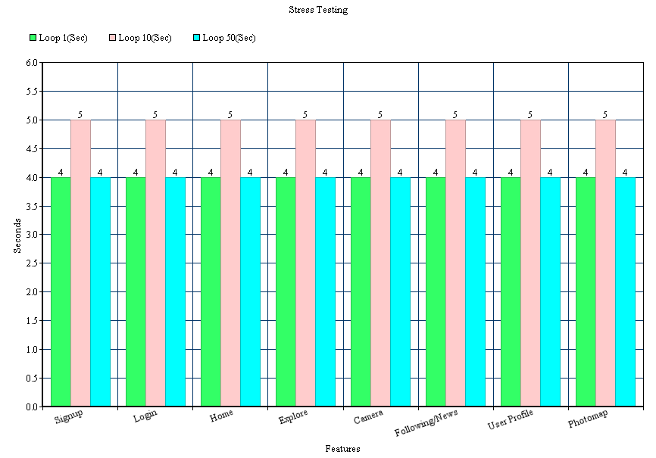

## Test cases for load testing -

|  |  |
| --- | --- |
| Test Case ID: LT-1 | Test Item: Instagram Native Mobile App |
| Tested by: Surbhi Rautji | Document Date: 12/1/2014 |
| Test Type: Load Testing | Test Suite: ST_1.1 |
| Product Name: Instagram Mobile App | Release and Version No: V 6.1.4 |
| Test Case Description: To test whether the Instagram Mobile native app works properly when the automated test scripts are run with one user under 3G connectivity | |
| Specifications | |
| Operation Procedure:  Install the Instagram app in the mobile device.  Connect to Neoload- node | |
| Pre-conditions: Start the navigation on Instagram Mobile app. | Post-conditions: To validate the required time for the script to run |
| Input data and/ or events: The data is recorded in Neoload through navigation of application on the device | Expected Output data and/ or events: The test script runs properly and use the average time per visited page. |
| Required Test Scripts: IN_PR-iOS | |

|  |  |
| --- | --- |
| Test Case ID: LT-2 | Test Item: Instagram Native Mobile App |
| Tested by: Surbhi Rautji | Document Date: 12/1/2014 |
| Test Type: Load Testing | Test Suite: ST_1.1 |
| Product Name: Instagram Mobile App | Release and Version No: V 6.1.4 |
| Test Case Description: To test whether the Instagram Mobile native app works properly when the automated test scripts are run with one user under 4G connectivity | |
| Specifications | |
| Operation Procedure:  Install the Instagram app in the mobile device.  Connect to Neoload- node | |
| Pre-conditions: Start the navigation on Instagram Mobile app. | Post-conditions: To validate the required time for the script to run |
| Input data and/ or events: The data is recorded in Neoload through navigation of application on the device | Expected Output data and/ or events: The test script runs properly and use the average time per visited page. |
| Required Test Scripts: IN_PR-iOS | |

|  |  |
| --- | --- |
| Test Case ID: LT-3 | Test Item: Instagram Native Mobile App |
| Tested by: Surbhi Rautji | Document Date: 12/1/2014 |
| Test Type: Load Testing | Test Suite: ST_1.1 |
| Product Name: Instagram Mobile App | Release and Version No: V 6.1.4 |
| Test Case Description: To test whether the Instagram Mobile native app works properly when the automated test scripts are run with one user under WIFI connectivity | |
| Specifications | |
| Operation Procedure:  Install the Instagram app in the mobile device.  Connect to Neoload- node | |
| Pre-conditions: Start the navigation on Instagram Mobile app. | Post-conditions: To validate the required time for the script to run |
| Input data and/ or events: The data is recorded in Neoload through navigation of application on the device | Expected Output data and/ or events: The test script runs properly and use the average time per visited page. |
| Required Test Scripts: IN_PR-iOS | |

|  |  |
| --- | --- |
| Test Case ID: LT-4 | Test Item: Instagram Native Mobile App |
| Tested by: Surbhi Rautji | Document Date: 12/1/2014 |
| Test Type: Load Testing | Test Suite: ST_1.1 |
| Product Name: Instagram Mobile App | Release and Version No: V 6.1.4 |
| Test Case Description: To test whether the Instagram Mobile native app works properly when the automated test scripts are run with ten under 3G connectivity | |
| Specifications | |
| Operation Procedure:  Install the Instagram app in the mobile device.  Connect to Neoload- node | |
| Pre-conditions: Start the navigation on Instagram Mobile app. | Post-conditions: To validate the required time for the script to run |
| Input data and/ or events: The data is recorded in Neoload through navigation of application on the device | Expected Output data and/ or events: The test script runs properly and use the average time per visited page. |
| Required Test Scripts: IN_PR-iOS | |

|  |  |
| --- | --- |
| Test Case ID: LT-5 | Test Item: Instagram Native Mobile App |
| Tested by: Surbhi Rautji | Document Date: 12/1/2014 |
| Test Type: Load Testing | Test Suite: ST_1.1 |
| Product Name: Instagram Mobile App | Release and Version No: V 6.1.4 |
| Test Case Description: To test whether the Instagram Mobile native app works properly when the automated test scripts are run with ten user under 4G connectivity | |
| Specifications | |
| Operation Procedure:  Install the Instagram app in the mobile device.  Connect to Neoload- node | |
| Pre-conditions: Start the navigation on Instagram Mobile app. | Post-conditions: To validate the required time for the script to run |
| Input data and/ or events: The data is recorded in Neoload through navigation of application on the device | Expected Output data and/ or events: The test script runs properly and use the average time per visited page. |
| Required Test Scripts: IN_PR-iOS | |

|  |  |
| --- | --- |
| Test Case ID: LT-6 | Test Item: Instagram Native Mobile App |
| Tested by: Surbhi Rautji | Document Date: 12/1/2014 |
| Test Type: Load Testing | Test Suite: ST_1.1 |
| Product Name: Instagram Mobile App | Release and Version No: V 6.1.4 |
| Test Case Description: To test whether the Instagram Mobile native app works properly when the automated test scripts are run with ten user under WIFI connectivity | |
| Specifications | |
| Operation Procedure:  Install the Instagram app in the mobile device.  Connect to Neoload- node | |
| Pre-conditions: Start the navigation on Instagram Mobile app. | Post-conditions: To validate the required time for the script to run |
| Input data and/ or events: The data is recorded in Neoload through navigation of application on the device | Expected Output data and/ or events: The test script runs properly and use the average time per visited page. |
| Required Test Scripts: IN_PR-iOS | |

|  |  |
| --- | --- |
| Test Case ID: LT-7 | Test Item: Instagram Native Mobile App |
| Tested by: Surbhi Rautji | Document Date: 12/1/2014 |
| Test Type: Load Testing | Test Suite: ST_1.1 |
| Product Name: Instagram Mobile App | Release and Version No: V 6.1.4 |
| Test Case Description: To test whether the Instagram Mobile native app works properly when the automated test scripts are run with 50 user under 3G connectivity | |
| Specifications | |
| Operation Procedure:  Install the Instagram app in the mobile device.  Connect to Neoload- node | |
| Pre-conditions: Start the navigation on Instagram Mobile app. | Post-conditions: To validate the required time for the script to run |
| Input data and/ or events: The data is recorded in Neoload through navigation of application on the device | Expected Output data and/ or events: The test script runs properly and use the average time per visited page. |
| Required Test Scripts: IN_PR-iOS | |

|  |  |
| --- | --- |
| Test Case ID: LT-8 | Test Item: Instagram Native Mobile App |
| Tested by: Surbhi Rautji | Document Date: 12/1/2014 |
| Test Type: Load Testing | Test Suite: ST_1.1 |
| Product Name: Instagram Mobile App | Release and Version No: V 6.1.4 |
| Test Case Description: To test whether the Instagram Mobile native app works properly when the automated test scripts are run with 50 user under 4G connectivity | |
| Specifications | |
| Operation Procedure:  Install the Instagram app in the mobile device.  Connect to Neoload- node | |
| Pre-conditions: Start the navigation on Instagram Mobile app. | Post-conditions: To validate the required time for the script to run |
| Input data and/ or events: The data is recorded in Neoload through navigation of application on the device | Expected Output data and/ or events: The test script runs properly and use the average time per visited page. |
| Required Test Scripts: IN_PR-iOS | |

|  |  |
| --- | --- |
| Test Case ID: LT-9 | Test Item: Instagram Native Mobile App |
| Tested by: Surbhi Rautji | Document Date: 12/1/2014 |
| Test Type: Load Testing | Test Suite: ST_1.1 |
| Product Name: Instagram Mobile App | Release and Version No: V 6.1.4 |
| Test Case Description: To test whether the Instagram Mobile native app works properly when the automated test scripts are run with 50 user under WIFI connectivity | |
| Specifications | |
| Operation Procedure:  Install the Instagram app in the mobile device.  Connect to Neoload- node | |
| Pre-conditions: Start the navigation on Instagram Mobile app. | Post-conditions: To validate the required time for the script to run |
| Input data and/ or events: The data is recorded in Neoload through navigation of application on the device | Expected Output data and/ or events: The test script runs properly and use the average time per visited page. |
| Required Test Scripts: IN_PR-iOS | |

|  |  |
| --- | --- |
| Test Case ID: LT-10 | Test Item: Instagram Native Mobile App |
| Tested by: Surbhi Rautji | Document Date: 12/1/2014 |
| Test Type: Load Testing | Test Suite: ST_1.1 |
| Product Name: Instagram Mobile App | Release and Version No: V 6.1.4 |
| Test Case Description: To test whether the Instagram Mobile native app works properly when the automated test scripts are run with one user under 3G connectivity | |
| Specifications | |
| Operation Procedure:  Install the Instagram app in the mobile device.  Connect to Neoload- node | |
| Pre-conditions: Start the navigation on Instagram Mobile app. | Post-conditions: To validate the required time for the script to run |
| Input data and/ or events: The data is recorded in Neoload through navigation of application on the device | Expected Output data and/ or events: The test script runs properly and use the average time per visited page. |
| Required Test Scripts: IN_PR-ANDROID | |

|  |  |
| --- | --- |
| Test Case ID: LT-11 | Test Item: Instagram Native Mobile App |
| Tested by: Surbhi Rautji | Document Date: 12/1/2014 |
| Test Type: Load Testing | Test Suite: ST_1.1 |
| Product Name: Instagram Mobile App | Release and Version No: V 6.1.4 |
| Test Case Description: To test whether the Instagram Mobile native app works properly when the automated test scripts are run with one user under 4G connectivity | |
| Specifications | |
| Operation Procedure:  Install the Instagram app in the mobile device.  Connect to Neoload- node | |
| Pre-conditions: Start the navigation on Instagram Mobile app. | Post-conditions: To validate the required time for the script to run |
| Input data and/ or events: The data is recorded in Neoload through navigation of application on the device | Expected Output data and/ or events: The test script runs properly and use the average time per visited page. |
| Required Test Scripts: IN_PR- ANDROID | |

|  |  |
| --- | --- |
| Test Case ID: LT-12 | Test Item: Instagram Native Mobile App |
| Tested by: Surbhi Rautji | Document Date: 12/1/2014 |
| Test Type: Load Testing | Test Suite: ST_1.1 |
| Product Name: Instagram Mobile App | Release and Version No: V 6.1.4 |
| Test Case Description: To test whether the Instagram Mobile native app works properly when the automated test scripts are run with one user under WIFI connectivity | |
| Specifications | |
| Operation Procedure:  Install the Instagram app in the mobile device.  Connect to Neoload- node | |
| Pre-conditions: Start the navigation on Instagram Mobile app. | Post-conditions: To validate the required time for the script to run |
| Input data and/ or events: The data is recorded in Neoload through navigation of application on the device | Expected Output data and/ or events: The test script runs properly and use the average time per visited page. |
| Required Test Scripts: IN_PR- ANDROID | |

|  |  |
| --- | --- |
| Test Case ID: LT-13 | Test Item: Instagram Native Mobile App |
| Tested by: Surbhi Rautji | Document Date: 12/1/2014 |
| Test Type: Load Testing | Test Suite: ST_1.1 |
| Product Name: Instagram Mobile App | Release and Version No: V 6.1.4 |
| Test Case Description: To test whether the Instagram Mobile native app works properly when the automated test scripts are run with ten under 3G connectivity | |
| Specifications | |
| Operation Procedure:  Install the Instagram app in the mobile device.  Connect to Neoload- node | |
| Pre-conditions: Start the navigation on Instagram Mobile app. | Post-conditions: To validate the required time for the script to run |
| Input data and/ or events: The data is recorded in Neoload through navigation of application on the device | Expected Output data and/ or events: The test script runs properly and use the average time per visited page. |
| Required Test Scripts: IN_PR- ANDROID | |

|  |  |
| --- | --- |
| Test Case ID: LT-14 | Test Item: Instagram Native Mobile App |
| Tested by: Surbhi Rautji | Document Date: 112/1/2014 |
| Test Type: Load Testing | Test Suite: ST_1.1 |
| Product Name: Instagram Mobile App | Release and Version No: V 6.1.4 |
| Test Case Description: To test whether the Instagram Mobile native app works properly when the automated test scripts are run with ten user under 4G connectivity | |
| Specifications | |
| Operation Procedure:  Install the Instagram app in the mobile device.  Connect to Neoload- node | |
| Pre-conditions: Start the navigation on Instagram Mobile app. | Post-conditions: To validate the required time for the script to run |
| Input data and/ or events: The data is recorded in Neoload through navigation of application on the device | Expected Output data and/ or events: The test script runs properly and use the average time per visited page. |
| Required Test Scripts: IN_PR- ANDROID | |

|  |  |
| --- | --- |
| Test Case ID: LT-15 | Test Item: Instagram Native Mobile App |
| Tested by: Surbhi Rautji | Document Date: 12/1/2014 |
| Test Type: Load Testing | Test Suite: ST_1.1 |
| Product Name: Instagram Mobile App | Release and Version No: V 6.1.4 |
| Test Case Description: To test whether the Instagram Mobile native app works properly when the automated test scripts are run with ten user under WIFI connectivity | |
| Specifications | |
| Operation Procedure:  Install the Instagram app in the mobile device.  Connect to Neoload- node | |
| Pre-conditions: Start the navigation on Instagram Mobile app. | Post-conditions: To validate the required time for the script to run |
| Input data and/ or events: The data is recorded in Neoload through navigation of application on the device | Expected Output data and/ or events: The test script runs properly and use the average time per visited page. |
| Required Test Scripts: IN_PR- ANDROID | |

|  |  |
| --- | --- |
| Test Case ID: LT-16 | Test Item: Instagram Native Mobile App |
| Tested by: Surbhi Rautji | Document Date: 12/1/2014 |
| Test Type: Load Testing | Test Suite: ST_1.1 |
| Product Name: Instagram Mobile App | Release and Version No: V 6.1.4 |
| Test Case Description: To test whether the Instagram Mobile native app works properly when the automated test scripts are run with 50 user under 3G connectivity | |
| Specifications | |
| Operation Procedure:  Install the Instagram app in the mobile device.  Connect to Neoload- node | |
| Pre-conditions: Start the navigation on Instagram Mobile app. | Post-conditions: To validate the required time for the script to run |
| Input data and/ or events: The data is recorded in Neoload through navigation of application on the device | Expected Output data and/ or events: The test script runs properly and use the average time per visited page. |
| Required Test Scripts: IN_PR- ANDROID | |

|  |  |
| --- | --- |
| Test Case ID: LT-17 | Test Item: Instagram Native Mobile App |
| Tested by: Surbhi Rautji | Document Date: 12/1/2014 |
| Test Type: Load Testing | Test Suite: ST_1.1 |
| Product Name: Instagram Mobile App | Release and Version No: V 6.1.4 |
| Test Case Description: To test whether the Instagram Mobile native app works properly when the automated test scripts are run with 50 user under 4G connectivity | |
| Specifications | |
| Operation Procedure:  Install the Instagram app in the mobile device.  Connect to Neoload- node | |
| Pre-conditions: Start the navigation on Instagram Mobile app. | Post-conditions: To validate the required time for the script to run |
| Input data and/ or events: The data is recorded in Neoload through navigation of application on the device | Expected Output data and/ or events: The test script runs properly and use the average time per visited page. |
| Required Test Scripts: IN_PR- ANDROID | |

|  |  |
| --- | --- |
| Test Case ID: LT-18 | Test Item: Instagram Native Mobile App |
| Tested by: Surbhi Rautji | Document Date: 12/1/2014 |
| Test Type: Load Testing | Test Suite: ST_1.1 |
| Product Name: Instagram Mobile App | Release and Version No: V 6.1.4 |
| Test Case Description: To test whether the Instagram Mobile native app works properly when the automated test scripts are run with 50 user under WIFI connectivity | |
| Specifications | |
| Operation Procedure:  Install the Instagram app in the mobile device.  Connect to Neoload- node | |
| Pre-conditions: Start the navigation on Instagram Mobile app. | Post-conditions: To validate the required time for the script to run |
| Input data and/ or events: The data is recorded in Neoload through navigation of application on the device | Expected Output data and/ or events: The test script runs properly and use the average time per visited page. |
| Required Test Scripts: IN_PR- ANDROID | |

## Test data for load testing -

|  |  |  |  |
| --- | --- | --- | --- |
| **Features** | **User 1(sec)** | **Average of User 10(sec)** | **Average of User 50 (sec)** |
| Sign up | 104 | 103 | 105 |
| Login | 65 | 66 | 64 |
| Home | 70 | 68 | 72 |
| Explore | 50 | 52 | 54 |
| Camera | 66 | 68 | 65 |
| Following/News | 80 | 75 | 78 |
| User profile | 90 | 85 | 88 |
| Photomap | 85 | 96 | 92 |

## Test results for load testing -

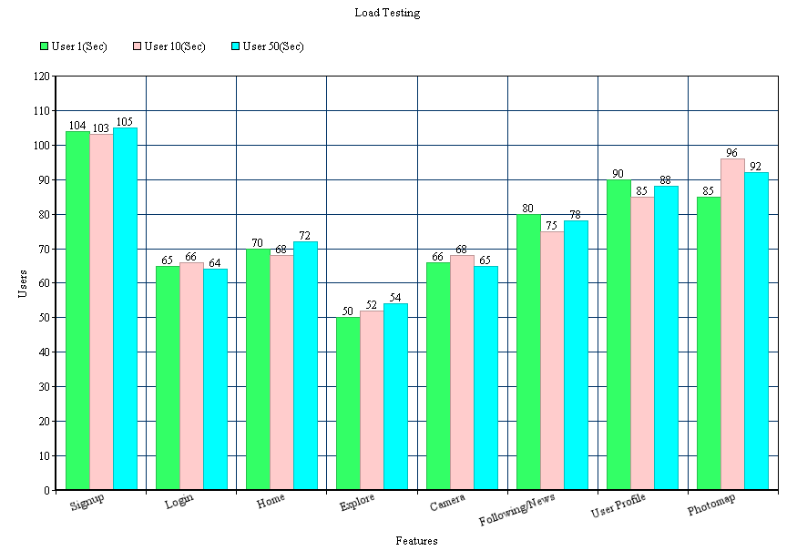

## **Automation functional Test scripts–**

We used Pefecto Mobile to create our automated GUI test scripts. Instagram is a native mobile application which has been tested on the device for Android and emulator for IOS. For doing the testing in Perfecto Mobile we need an account on perfectomobile.

In our automation testing we are able to take up maximum all the GUI feature of application like Sign up, Login, Camera, and Editing User Profile feature of the Instagram application. We also automated the Location based feature of the Instagram which include uploading photo on map, deleting photo from the map.

## Automated test scripts-

## Automated test scripts for IOS -

|  |  |  |  |  |
| --- | --- | --- | --- | --- |
| Test Case ID: | INM-IOS-AUTO1 | Test Name: | | Add Account |
| Written By: | Divanshu Arneja | Document Date: | | 12/03/2014 |
| Test Type: | Automation- Black Box Testing | Test Suite: | | Sign Up Component |
| Product Name: | Instagram | Release and Version no: | | V6.1.4 |
| Description: The test case is used to test the automation of sign up feature. | | | | |
| Procedure: | | | | |
| Pre-Condition: User should have an account on Instagram. Username and password entered should be valid. | | | Post Condition: | |
| Input Data: Script_Number1 | | | Expected Output: The Sign Up feature executed successfully. | |
| Required Test Script: Requirement Specification. | | | | |

|  |  |  |  |  |
| --- | --- | --- | --- | --- |
| Test Case ID: | INM-IOS-AUTO2 | Test Name: | | Login |
| Written By: | Divanshu Arneja | Document Date: | | 12/03/2014 |
| Test Type: | Automation- Black Box Testing | Test Suite: | | Component |
| Product Name: | Instagram | Release and Version no: | | V6.1.4 |
| Description: The test case is used to test the automation of login feature in instagram. | | | | |
| Procedure: | | | | |
| Pre-Condition: User should have an account on Instagram. Username and password entered should be valid. | | | Post Condition: | |
| Input Data: Script_Number2 | | | Expected Output: The login script  Executed successfully. | |
| Required Test Script: Requirement Specification. | | | | |

|  |  |  |  |  |
| --- | --- | --- | --- | --- |
| Test Case ID: | INM-IOS-AUTO3 | Test Name: | | Click Picture |
| Written By: | Divanshu Arneja | Document Date: | | 12/03/2014 |
| Test Type: | Automation- Black Box Testing | Test Suite: | | Camera Component |
| Product Name: | Instagram | Release and Version no: | | V6.1.4 |
| Description: The test case is used to test the automation of clicking a picture in instagram. | | | | |
| Procedure: | | | | |
| Pre-Condition: User should have an account on Instagram. Username and password entered should be valid. | | | Post Condition: | |
| Input Data: Script_Number3 | | | Expected Output: Picture is clicked. | |
| Required Test Script: Requirement Specification. | | | | |

|  |  |  |  |  |
| --- | --- | --- | --- | --- |
| Test Case ID: | INM-IOS-AUTO4 | Test Name: | | Tag User |
| Written By: | Divanshu Arneja | Document Date: | | 12/03/2014 |
| Test Type: | Automation- Black Box Testing | Test Suite: | | Camera Component |
| Product Name: | Instagram | Release and Version no: | | V6.1.4 |
| Description: The test case is used to test the automation clicking a picture and tag an existing user to it in instagram. | | | | |
| Procedure: | | | | |
| Pre-Condition: User should have an account on Instagram. Username and password entered should be valid. | | | Post Condition: | |
| Input Data: Script_Number4 | | | Expected Output: Picture is clicked and existing user is tagged successfully. | |
| Required Test Script: Requirement Specification. | | | | |

|  |  |  |  |  |
| --- | --- | --- | --- | --- |
| Test Case ID: | INM-IOS-AUTO5 | Test Name: | | Like Photo |
| Written By: | Divanshu Arneja | Document Date: | | 12/03/2014 |
| Test Type: | Automation- Black Box Testing | Test Suite: | | Home Component |
| Product Name: | Instagram | Release and Version no: | | V6.1.4 |
| Description: The test case is used to test the automation of like on a picture in instagram. | | | | |
| Procedure: | | | | |
| Pre-Condition: User should have an account on Instagram. Username and password entered should be valid. | | | Post Condition: | |
| Input Data: Script_Number5 | | | Expected Output: Picture is liked successfully. | |
| Required Test Script: Requirement Specification. | | | | |

|  |  |  |  |  |
| --- | --- | --- | --- | --- |
| Test Case ID: | INM-IOS-AUTO6 | Test Name: | | Unlike Photo |
| Written By: | Divanshu Arneja | Document Date: | | 12/03/2014 |
| Test Type: | Automation- Black Box Testing | Test Suite: | | Home Component |
| Product Name: | Instagram | Release and Version no: | | V6.1.4 |
| Description: The test case is used to test the automation of unlike a picture in instagram. | | | | |
| Procedure: | | | | |
| Pre-Condition: User should have an account on Instagram. Username and password entered should be valid. | | | Post Condition: | |
| Input Data: Script_Number6 | | | Expected Output: Liked Picture is unlike successfully. | |
| Required Test Script: Requirement Specification. | | | | |

|  |  |  |  |  |
| --- | --- | --- | --- | --- |
| Test Case ID: | INM-IOS-AUTO7 | Test Name: | | Comment Photo |
| Written By: | Divanshu Arneja | Document Date: | | 12/03/2014 |
| Test Type: | Automation- Black Box Testing | Test Suite: | | Home Component |
| Product Name: | Instagram | Release and Version no: | | V6.1.4 |
| Description: The test case is used to test the automation of adding a comment to a picture in instagram. | | | | |
| Procedure: | | | | |
| Pre-Condition: User should have an account on Instagram. Username and password entered should be valid. | | | Post Condition: | |
| Input Data: Script_Number7 | | | Expected Output: Comment is added successfully. | |
| Required Test Script: Requirement Specification. | | | | |

|  |  |  |  |  |
| --- | --- | --- | --- | --- |
| Test Case ID: | INM-IOS-AUTO8 | Test Name: | | Edit Profile Photo |
| Written By: | Divanshu Arneja | Document Date: | | 12/03/2014 |
| Test Type: | Automation- Black Box Testing | Test Suite: | | User Profile Component |
| Product Name: | Instagram | Release and Version no: | | V6.1.4 |
| Description: The test case is used to test the automation of updating profile picture by clicking it from camera in instagram. | | | | |
| Procedure: | | | | |
| Pre-Condition: User should have an account on Instagram. Username and password entered should be valid. | | | Post Condition: | |
| Input Data: Script_Number8 | | | Expected Output: Profile picture is updated successfully. | |
| Required Test Script: Requirement Specification. | | | | |

|  |  |  |  |  |
| --- | --- | --- | --- | --- |
| Test Case ID: | INM-IOS-AUTO9 | Test Name: | | Edit Profile Photo |
| Written By: | Divanshu Arneja | Document Date: | | 12/03/2014 |
| Test Type: | Automation- Black Box Testing | Status | | User Profile Component |
| Product Name: | Instagram | Release and Version no: | | V6.1.4 |
| Description: The test case is used to test the automation of updating profile picture by choosing it from phone gallery in instagram. | | | | |
| Procedure: | | | | |
| Pre-Condition: User should have an account on Instagram. Username and password entered should be valid. | | | Post Condition: | |
| Input Data: Script_Number9 | | | Expected Output: Profile picture is updated successfully. | |
| Required Test Script: Requirement Specification. | | | | |

|  |  |  |  |  |
| --- | --- | --- | --- | --- |
| Test Case ID: | INM-IOS-AUTO10 | Test Name: | | Search User |
| Written By: | Divanshu Arneja | Document Date: | | 12/03/2014 |
| Test Type: | Automation- Black Box Testing | Test Suit | | Explore Component |
| Product Name: | Instagram | Release and Version no: | | V6.1.4 |
| Description: The test case is used to test the automation of searching an existing user in instagram. | | | | |
| Procedure: | | | | |
| Pre-Condition: User should have an account on Instagram. Username and password entered should be valid. | | | Post Condition: | |
| Input Data: Script_Number10 | | | Expected Output: User is searched successfully. | |
| Required Test Script: Requirement Specification. | | | | |

|  |  |  |  |  |
| --- | --- | --- | --- | --- |
| Test Case ID: | INM-IOS-AUTO11 | Test Name: | | Zoom In Photo Map |
| Written By: | Divanshu Arneja | Document Date: | | 12/03/2014 |
| Test Type: | Automation- Black Box Testing | Test Suit | | Location based Component |
| Product Name: | Instagram | Release and Version no: | | V6.1.4 |
| Description: The test case is used to test the automation of zooming in map in instagram. | | | | |
| Procedure: | | | | |
| Pre-Condition: User should have an account on Instagram. Username and password entered should be valid. | | | Post Condition: | |
| Input Data: Script_Number11 | | | Expected Output: Map is zoomed in. | |
| Required Test Script: Requirement Specification. | | | | |

|  |  |  |  |  |
| --- | --- | --- | --- | --- |
| Test Case ID: | INM-IOS-AUTO12 | Test Name: | | Zoom Out PhotoMap |
| Written By: | Divanshu Arneja | Document Date: | | 12/03/2014 |
| Test Type: | Automation- Black Box Testing | Test Suit | | Location based Component |
| Product Name: | Instagram | Release and Version no: | | V6.1.4 |
| Description: The test case is used to test the automation of zooming out map in instagram. | | | | |
| Procedure: | | | | |
| Pre-Condition: User should have an account on Instagram. Username and password entered should be valid. | | | Post Condition: | |
| Input Data: Script_Number12 | | | Expected Output: Map is zoomed out successfully. | |
| Required Test Script: Requirement Specification. | | | | |

|  |  |  |  |  |
| --- | --- | --- | --- | --- |
| Test Case ID: | INM-IOS-AUTO13 | Test Name: | | Delete Photo from Photomap |
| Written By: | Divanshu Arneja | Document Date: | | 12/03/2014 |
| Test Type: | Automation- Black Box Testing | Test Suit | | Location based Component |
| Product Name: | Instagram | Release and Version no: | | V6.1.4 |
| Description: The test case is used to test the automation of deleting a photo from map in instagram. | | | | |
| Procedure: | | | | |
| Pre-Condition: User should have an account on Instagram. Username and password entered should be valid. | | | Post Condition: | |
| Input Data: Script_Number13 | | | Expected Output: Photo is deleted successfully. | |
| Required Test Script: Requirement Specification. | | | | |

|  |  |  |  |  |
| --- | --- | --- | --- | --- |
| Test Case ID: | INM-IOS-AUTO14 | Test Name: | | Add Photo to Photomap |
| Written By: | Divanshu Arneja | Document Date: | | 12/03/2014 |
| Test Type: | Automation- Black Box Testing | Test Suit | | Location based Component |
| Product Name: | Instagram | Release and Version no: | | V6.1.4 |
| Description: The test case is used to test the automation of deleting a photo from map in instagram. | | | | |
| Procedure: | | | | |
| Pre-Condition: User should have an account on Instagram. Username and password entered should be valid. | | | Post Condition: | |
| Input Data: Script_Number14 | | | Expected Output: Photo is deleted successfully. | |
| Required Test Script: Requirement Specification. | | | | |

## Automated test scripts for Android -

|  |  |  |  |  |
| --- | --- | --- | --- | --- |
| Test Case ID: | INM-AND-AUTO1 | Test Name: | | Add Account |
| Written By: | Shilpa | Document Date: | | 12/03/2014 |
| Test Type: | Automation- Black Box Testing | Test Suite: | | Sign Up Component |
| Product Name: | Instagram | Release and Version no: | | V6.1.4 |
| Description: The test case is used to test the automation of sign up feature. | | | | |
| Procedure: | | | | |
| Pre-Condition: User should have an account on Instagram. Username and password entered should be valid. | | | Post Condition: | |
| Input Data: Script_Number1 | | | Expected Output: The Sign Up feature executed successfully. | |
| Required Test Script: Requirement Specification. | | | | |

|  |  |  |  |  |
| --- | --- | --- | --- | --- |
| Test Case ID: | INM-AND-AUTO2 | Test Name: | | Login |
| Written By: | Shilpa | Document Date: | | 12/03/2014 |
| Test Type: | Automation- Black Box Testing | Test Suite: | | Component |
| Product Name: | Instagram | Release and Version no: | | V6.1.4 |
| Description: The test case is used to test the automation of login feature in instagram. | | | | |
| Procedure: | | | | |
| Pre-Condition: User should have an account on Instagram. Username and password entered should be valid. | | | Post Condition: | |
| Input Data: Script_Number2 | | | Expected Output: The login script  Executed successfully. | |
| Required Test Script: Requirement Specification. | | | | |

|  |  |  |  |  |
| --- | --- | --- | --- | --- |
| Test Case ID: | INM-AND-AUTO3 | Test Name: | | Click Picture |
| Written By: | Shilpa | Document Date: | | 12/03/2014 |
| Test Type: | Automation- Black Box Testing | Test Suite: | | Camera Component |
| Product Name: | Instagram | Release and Version no: | | V6.1.4 |
| Description: The test case is used to test the automation of clicking a picture in instagram. | | | | |
| Procedure: | | | | |
| Pre-Condition: User should have an account on Instagram. Username and password entered should be valid. | | | Post Condition: | |
| Input Data: Script_Number3 | | | Expected Output: Picture is clicked. | |
| Required Test Script: Requirement Specification. | | | | |
| Test Case ID: | INM-AND-AUTO4 | Test Name: | | Tag User |
| Written By: | Shilpa | Document Date: | | 12/03/2014 |
| Test Type: | Automation- Black Box Testing | Test Suite: | | Camera Component |
| Product Name: | Instagram | Release and Version no: | | V6.1.4 |
| Description: The test case is used to test the automation clicking a picture and tag an existing user to it in instagram. | | | | |
| Procedure: | | | | |
| Pre-Condition: User should have an account on Instagram. Username and password entered should be valid. | | | Post Condition: | |
| Input Data: Script_Number4 | | | Expected Output: Picture is clicked and existing user is tagged successfully. | |
| Required Test Script: Requirement Specification. | | | | |

|  |  |  |  |  |
| --- | --- | --- | --- | --- |
| Test Case ID: | INM-AND-AUTO5 | Test Name: | | Like Photo |
| Written By: | Shilpa | Document Date: | | 12/03/2014 |
| Test Type: | Automation- Black Box Testing | Test Suite: | | Home Component |
| Product Name: | Instagram | Release and Version no: | | V6.1.4 |
| Description: The test case is used to test the automation of like on a picture in instagram. | | | | |
| Procedure: | | | | |
| Pre-Condition: User should have an account on Instagram. Username and password entered should be valid. | | | Post Condition: | |
| Input Data: Script_Number5 | | | Expected Output: Picture is liked successfully. | |
| Required Test Script: Requirement Specification. | | | | |

|  |  |  |  |  |
| --- | --- | --- | --- | --- |
| Test Case ID: | INM-AND-AUTO6 | Test Name: | | Unlike Photo |
| Written By: | Shilpa | Document Date: | | 12/03/2014 |
| Test Type: | Automation- Black Box Testing | Test Suite: | | Home Component |
| Product Name: | Instagram | Release and Version no: | | V6.1.4 |
| Description: The test case is used to test the automation of unlike a picture in instagram. | | | | |
| Procedure: | | | | |
| Pre-Condition: User should have an account on Instagram. Username and password entered should be valid. | | | Post Condition: | |
| Input Data: Script_Number6 | | | Expected Output: Liked Picture is unlike successfully. | |
| Required Test Script: Requirement Specification. | | | | |

|  |  |  |  |  |
| --- | --- | --- | --- | --- |
| Test Case ID: | INM-AND-AUTO7 | Test Name: | | Comment Photo |
| Written By: | Shilpa | Document Date: | | 12/03/2014 |
| Test Type: | Automation- Black Box Testing | Test Suite: | | Home Component |
| Product Name: | Instagram | Release and Version no: | | V6.1.4 |
| Description: The test case is used to test the automation of adding a comment to a picture in instagram. | | | | |
| Procedure: | | | | |
| Pre-Condition: User should have an account on Instagram. Username and password entered should be valid. | | | Post Condition: | |
| Input Data: Script_Number7 | | | Expected Output: Comment is added successfully. | |
| Required Test Script: Requirement Specification. | | | | |

|  |  |  |  |  |
| --- | --- | --- | --- | --- |
| Test Case ID: | INM-AND-AUTO8 | Test Name: | | Edit Profile Photo |
| Written By: | Shilpa | Document Date: | | 12/03/2014 |
| Test Type: | Automation- Black Box Testing | Test Suite: | | User Profile Component |
| Product Name: | Instagram | Release and Version no: | | V6.1.4 |
| Description: The test case is used to test the automation of updating profile picture by clicking it from camera in instagram. | | | | |
| Procedure: | | | | |
| Pre-Condition: User should have an account on Instagram. Username and password entered should be valid. | | | Post Condition: | |
| Input Data: Script_Number8 | | | Expected Output: Profile picture is updated successfully. | |
| Required Test Script: Requirement Specification. | | | | |

|  |  |  |  |  |
| --- | --- | --- | --- | --- |
| Test Case ID: | INM-AND-AUTO9 | Test Name: | | Edit Profile Photo |
| Written By: | Shilpa | Document Date: | | 12/03/2014 |
| Test Type: | Automation- Black Box Testing | Status | | User Profile Component |
| Product Name: | Instagram | Release and Version no: | | V6.1.4 |
| Description: The test case is used to test the automation of updating profile picture by choosing it from phone gallery in instagram. | | | | |
| Procedure: | | | | |
| Pre-Condition: User should have an account on Instagram. Username and password entered should be valid. | | | Post Condition: | |
| Input Data: Script_Number9 | | | Expected Output: Profile picture is updated successfully. | |
| Required Test Script: Requirement Specification. | | | | |

|  |  |  |  |  |
| --- | --- | --- | --- | --- |
| Test Case ID: | INM-AND-AUTO10 | Test Name: | | Search User |
| Written By: | Shilpa | Document Date: | | 12/03/2014 |
| Test Type: | Automation- Black Box Testing | Test Suit | | Explore Component |
| Product Name: | Instagram | Release and Version no: | | V6.1.4 |
| Description: The test case is used to test the automation of searching an existing user in instagram. | | | | |
| Procedure: | | | | |
| Pre-Condition: User should have an account on Instagram. Username and password entered should be valid. | | | Post Condition: | |
| Input Data: Script_Number10 | | | Expected Output: User is searched successfully. | |
| Required Test Script: Requirement Specification. | | | | |

|  |  |  |  |  |
| --- | --- | --- | --- | --- |
| Test Case ID: | INM-AND-AUTO11 | Test Name: | | Zoom In Photo Map |
| Written By: | Shilpa | Document Date: | | 12/03/2014 |
| Test Type: | Automation- Black Box Testing | Test Suit | | Location based Component |
| Product Name: | Instagram | Release and Version no: | | V6.1.4 |
| Description: The test case is used to test the automation of zooming in map in instagram. | | | | |
| Procedure: | | | | |
| Pre-Condition: User should have an account on Instagram. Username and password entered should be valid. | | | Post Condition: | |
| Input Data: Script_Number11 | | | Expected Output: Map is zoomed in. | |
| Required Test Script: Requirement Specification. | | | | |

|  |  |  |  |  |
| --- | --- | --- | --- | --- |
| Test Case ID: | INM-AND-AUTO12 | Test Name: | | Zoom Out PhotoMap |
| Written By: | Shilpa | Document Date: | | 12/03/2014 |
| Test Type: | Automation- Black Box Testing | Test Suit | | Location based Component |
| Product Name: | Instagram | Release and Version no: | | V6.1.4 |
| Description: The test case is used to test the automation of zooming out map in instagram. | | | | |
| Procedure: | | | | |
| Pre-Condition: User should have an account on Instagram. Username and password entered should be valid. | | | Post Condition: | |
| Input Data: Script_Number12 | | | Expected Output: Map is zoomed out successfully. | |
| Required Test Script: Requirement Specification. | | | | |

|  |  |  |  |  |
| --- | --- | --- | --- | --- |
| Test Case ID: | INM-AND-AUTO13 | Test Name: | | Delete Photo from Photomap |
| Written By: | Shilpa | Document Date: | | 12/03/2014 |
| Test Type: | Automation- Black Box Testing | Test Suit | | Location based Component |
| Product Name: | Instagram | Release and Version no: | | V6.1.4 |
| Description: The test case is used to test the automation of deleting a photo from map in instagram. | | | | |
| Procedure: | | | | |
| Pre-Condition: User should have an account on Instagram. Username and password entered should be valid. | | | Post Condition: | |
| Input Data: Script_Number13 | | | Expected Output: Photo is deleted successfully. | |
| Required Test Script: Requirement Specification. | | | | |

## Summary of test results -

## Summary of test results for IOS -

|  |  |  |  |  |
| --- | --- | --- | --- | --- |
| Test Case ID | Version | Testing Environment | Test Script ID | Result |
| INM-IOS-AUTO1 | 6.1.4 | IOS | Script_number1 | Pass |
| INM-IOS-AUTO2 | 6.1.4 | IOS | Script_number2 | Pass |
| INM-IOS-AUTO3 | 6.1.4 | IOS | Script_number3 | Pass |
| INM-IOS-AUTO4 | 6.1.4 | IOS | Script_number4 | Pass |
| INM-IOS-AUTO5 | 6.1.4 | IOS | Script_number5 | Pass |
| INM-IOS-AUTO6 | 6.1.4 | IOS | Script_number6 | Pass |
| INM-IOS-AUTO7 | 6.1.4 | IOS | Script_number7 | Pass |
| INM-IOS-AUTO8 | 6.1.4 | IOS | Script_number8 | Pass |
| INM-IOS-AUTO9 | 6.1.4 | IOS | Script_number9 | Pass |
| INM-IOS-AUTO10 | 6.1.4 | IOS | Script_number10 | Pass |
| INM-IOS-AUTO11 | 6.1.4 | IOS | Script_number11 | Pass |
| INM-IOS-AUTO12 | 6.1.4 | IOS | Script_number12 | Pass |
| INM-IOS-AUTO13 | 6.1.4 | IOS | Script_number13 | Pass |
| INM-IOS-AUTO14 | 6.1.4 | IOS | Script_number14 | Pass |

## Summary of test results for Android -

|  |  |  |  |  |
| --- | --- | --- | --- | --- |
| Test Case ID | Version | Testing Environment | Test Script ID | Result |
| INM-AND-AUTO1 | 6.1.4 | ANDROID | Script_number1 | Pass |
| INM-AND-AUTO2 | 6.1.4 | ANDROID | Script_number2 | Pass |
| INM-AND-AUTO3 | 6.1.4 | ANDROID | Script_number3 | Pass |
| INM-AND-AUTO4 | 6.1.4 | ANDROID | Script_number4 | Pass |
| INM-AND-AUTO5 | 6.1.4 | ANDROID | Script_number5 | Pass |
| INM-AND-AUTO6 | 6.1.4 | ANDROID | Script_number6 | Pass |
| INM-AND-AUTO7 | 6.1.4 | ANDROID | Script_number7 | Pass |
| INM-AND-AUTO8 | 6.1.4 | ANDROID | Script_number8 | Pass |
| INM-AND-AUTO9 | 6.1.4 | ANDROID | Script_number9 | Pass |
| INM-AND-AUTO10 | 6.1.4 | ANDROID | Script_number10 | Pass |
| INM-AND-AUTO11 | 6.1.4 | ANDROID | Script_number11 | Pass |
| INM-AND-AUTO12 | 6.1.4 | ANDROID | Script_number12 | Pass |
| INM-AND-AUTO13 | 6.1.4 | ANDROID | Script_number13 | Pass |

## **Automation Test results and Summary–**

## Scripts for IOS -

1)

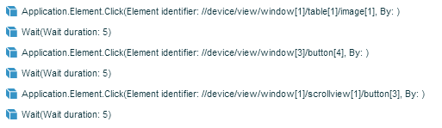

2)

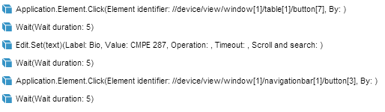

3)

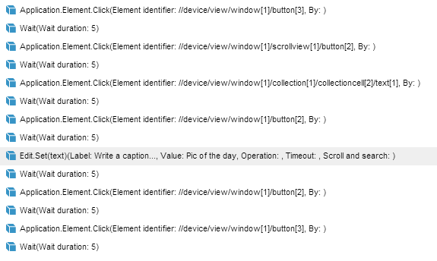

4)

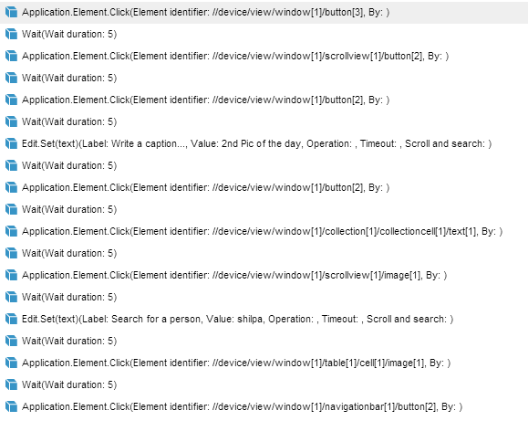

5)

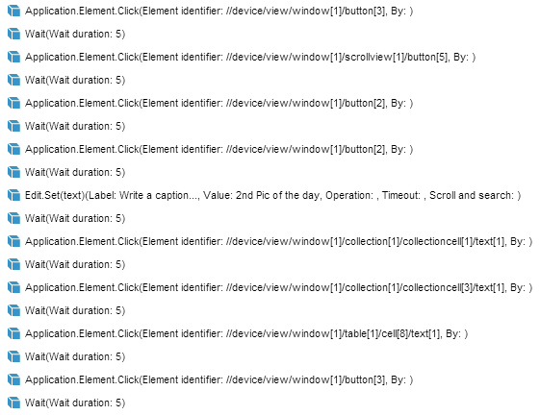

6)

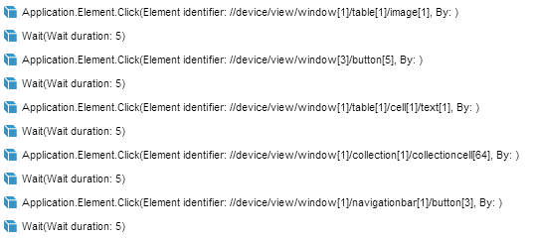

7)



8)

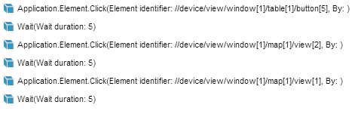

9)

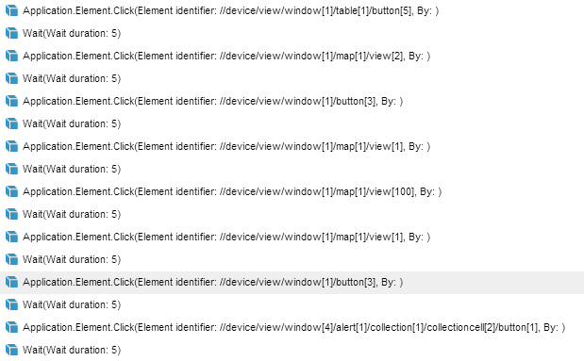

10)

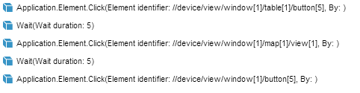

11)

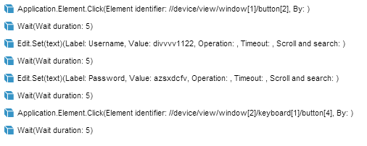

12)

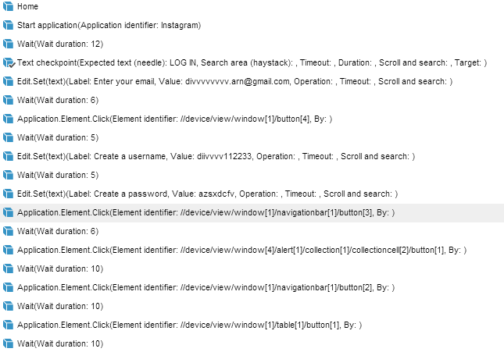

13)



14)



## Scripts for Android-

1)



2)



3)



4)



5)



6)



7)



8)



9)



10)



11)



12)



13)

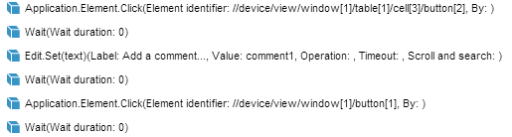

## Functionality results -

**Signup**

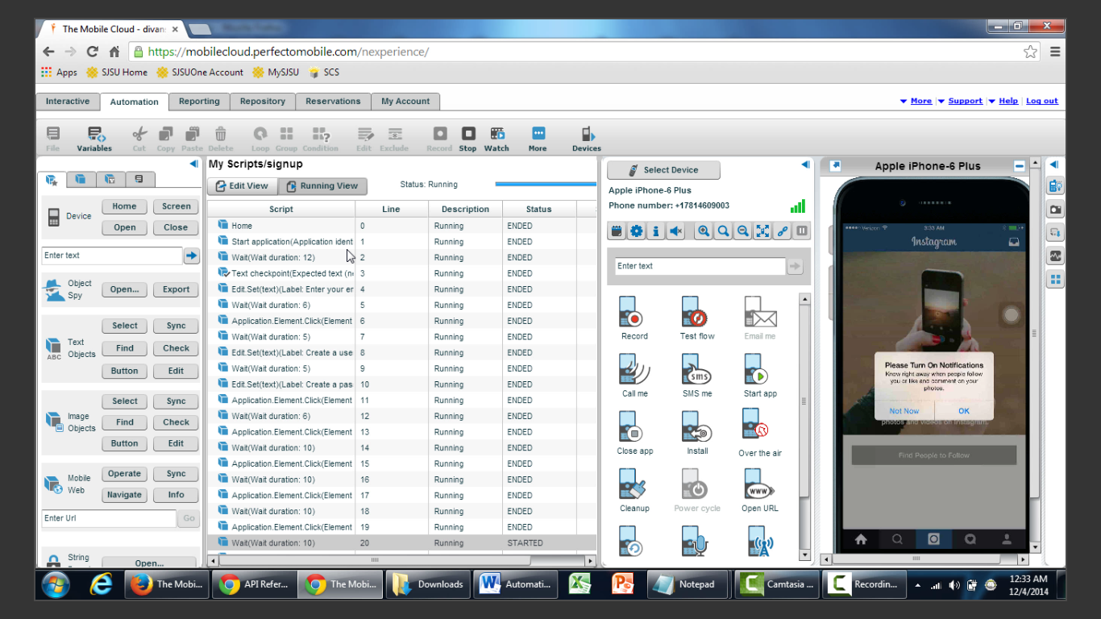

**Login**

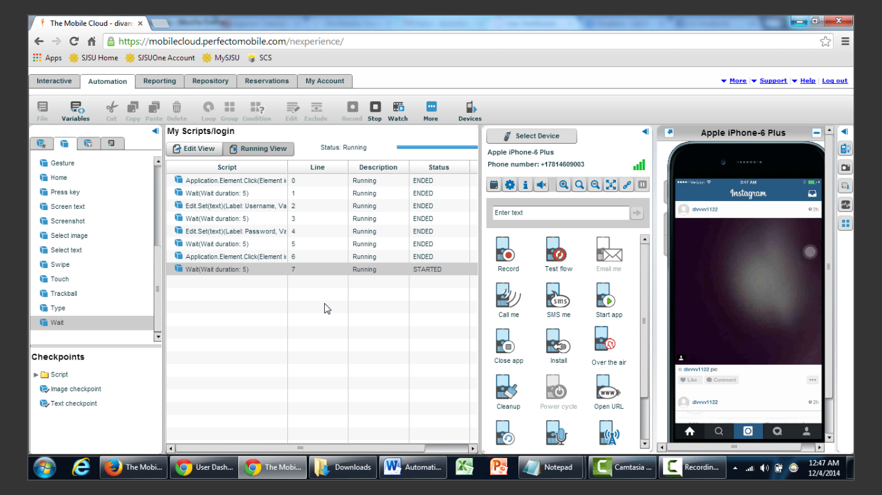

**Click picture**

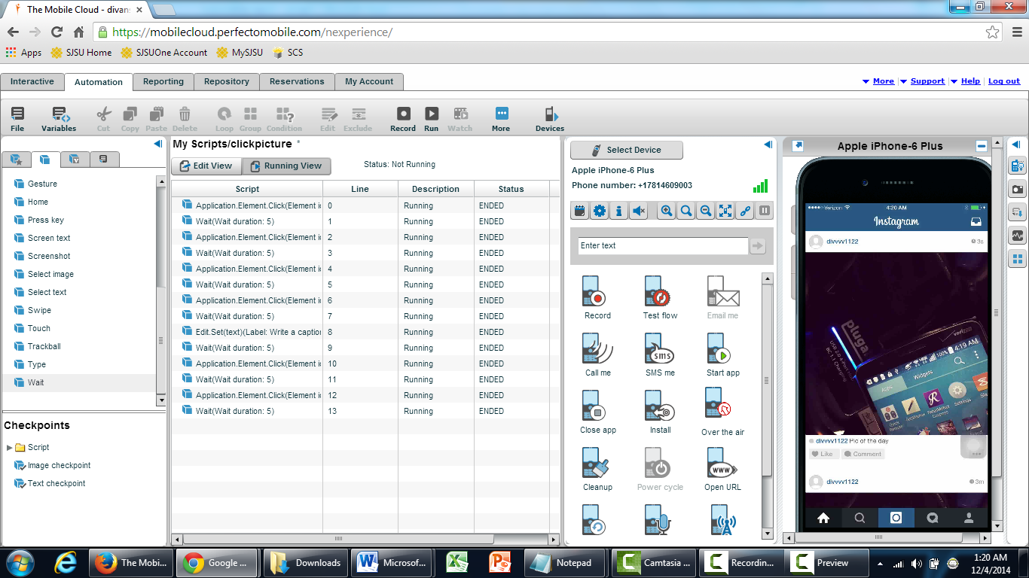

**Click pic and tag**

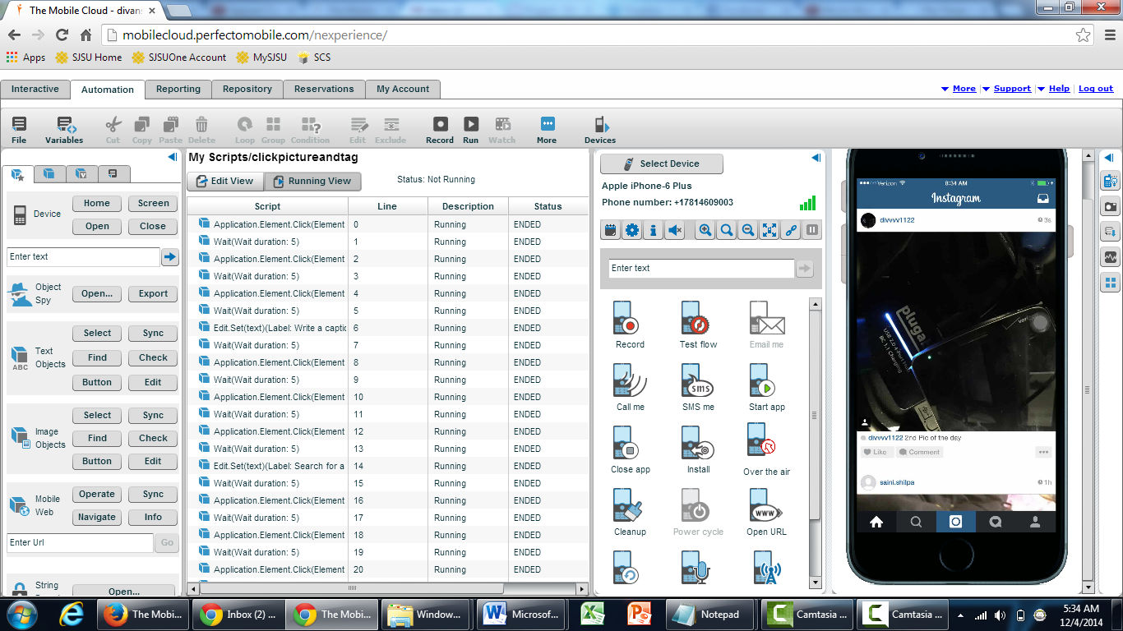

**Click pic and share on a location**

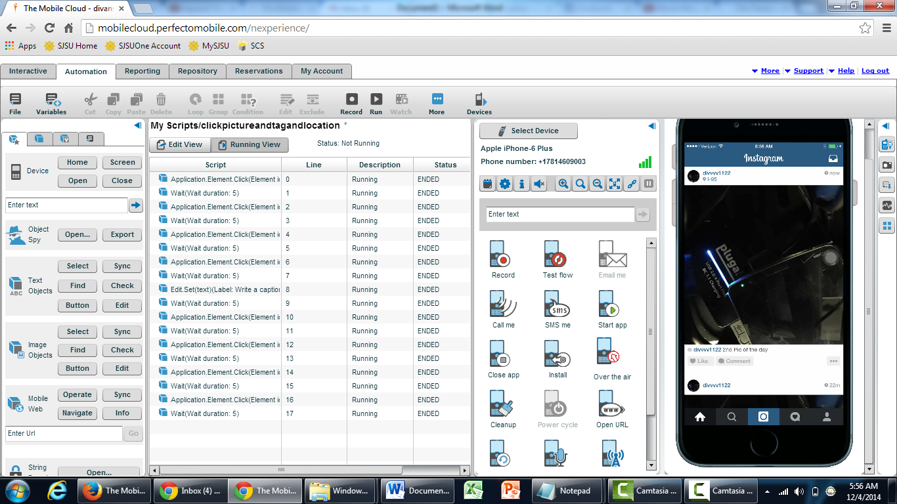

**Location based 1**

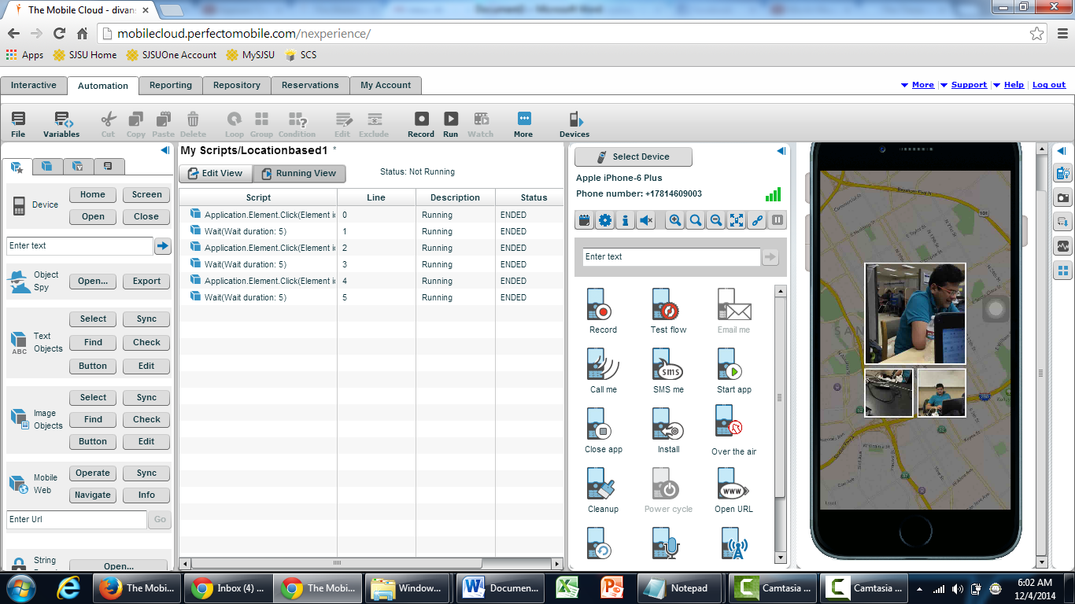

**Location based 2**

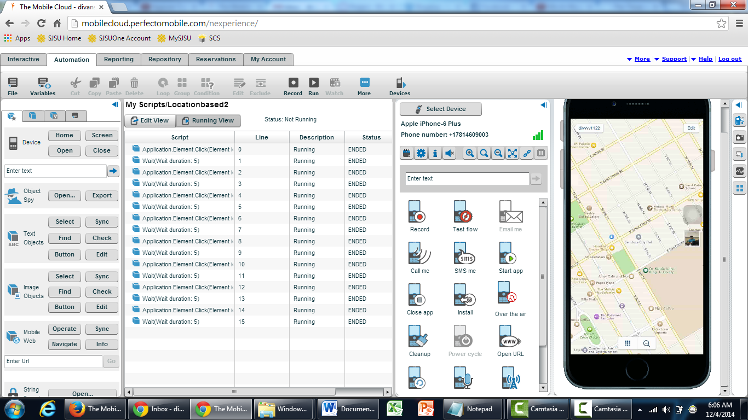

**Location based 3**

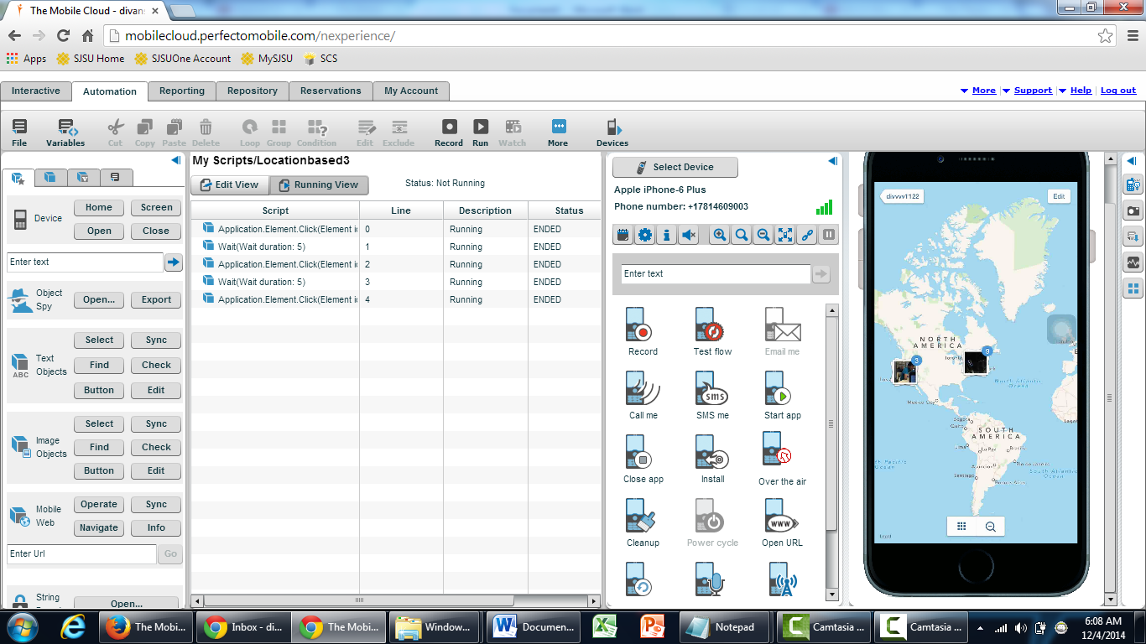

**Followers**

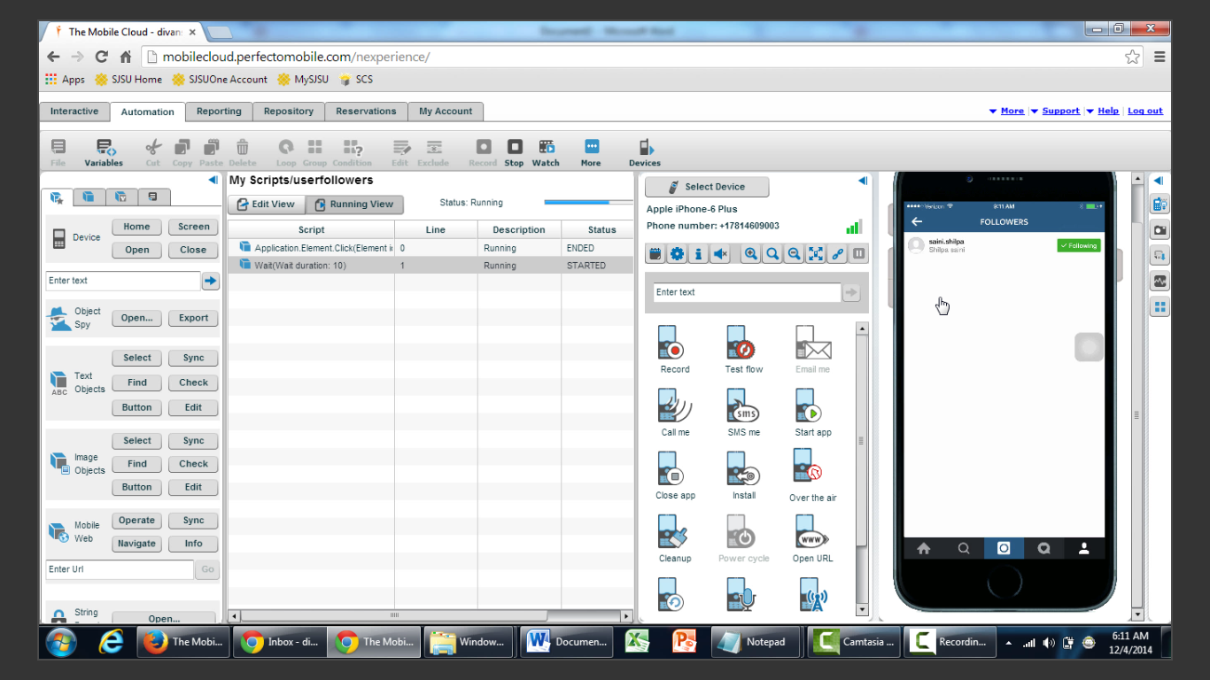

**Following**

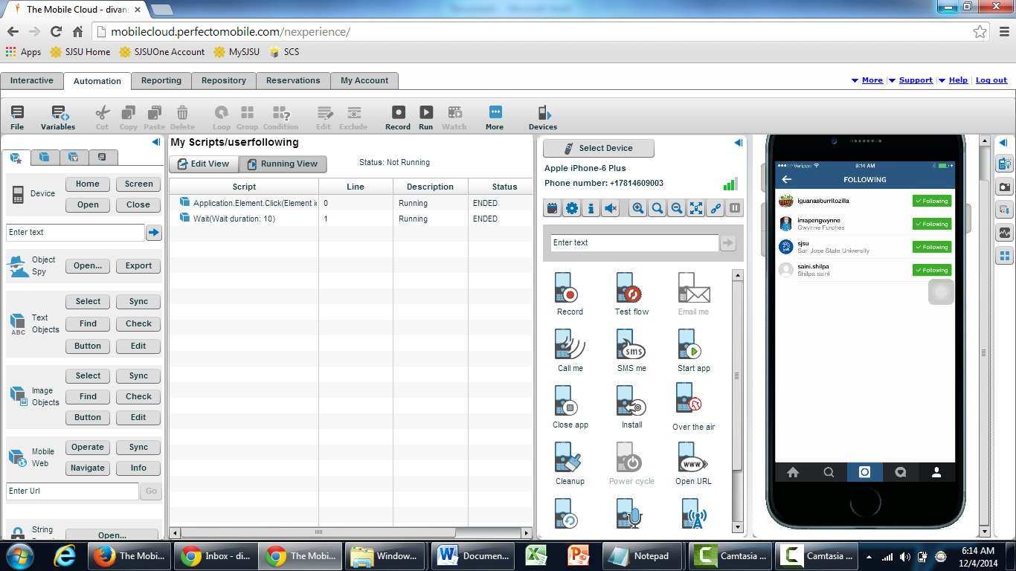

**Like**

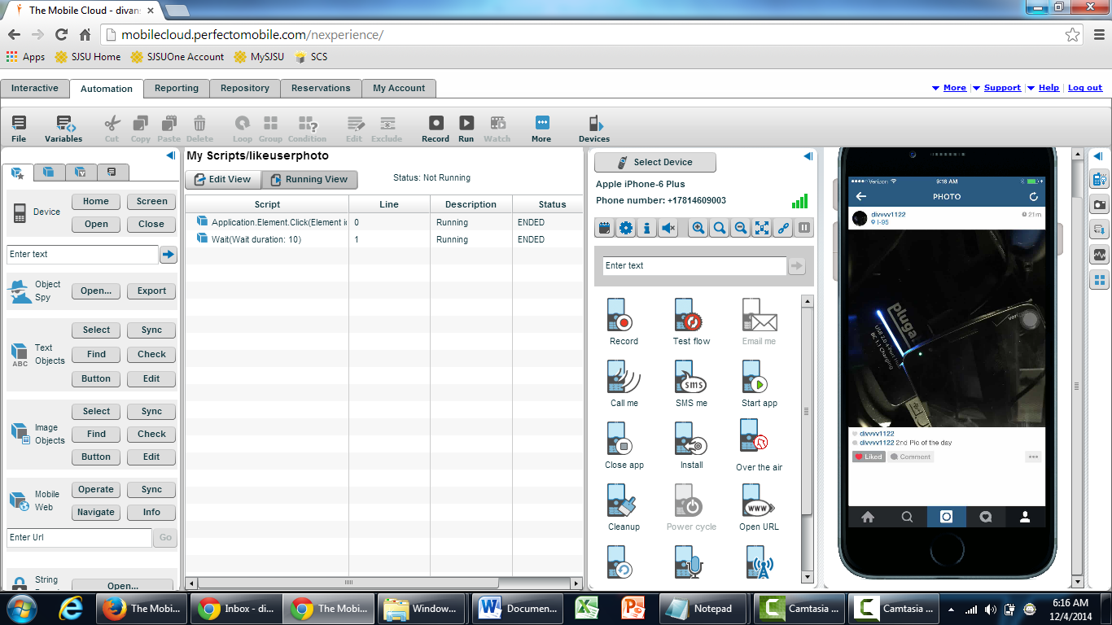

**Unlike**

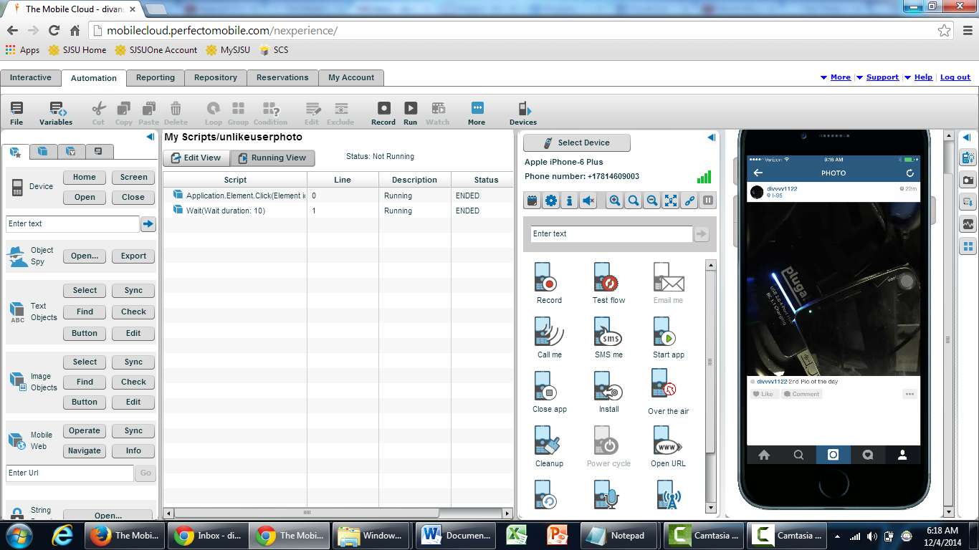

**Comment**

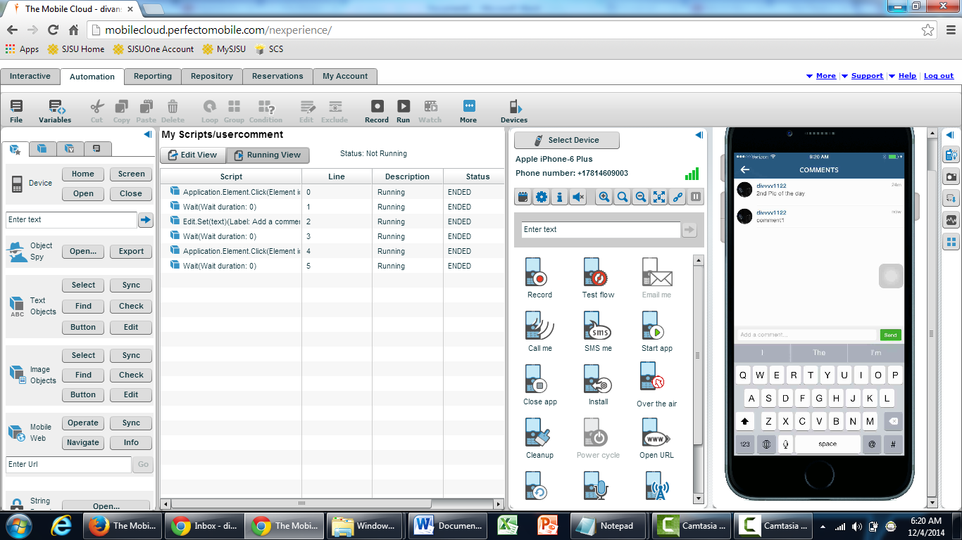

**Change pic**

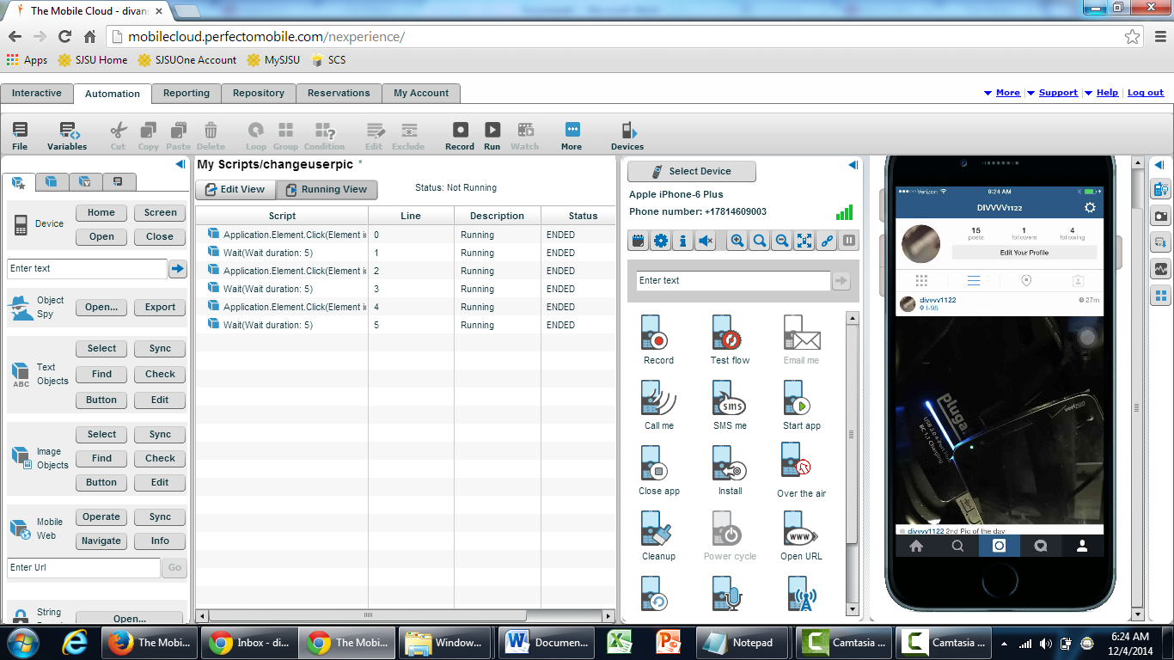

**Change pic1**

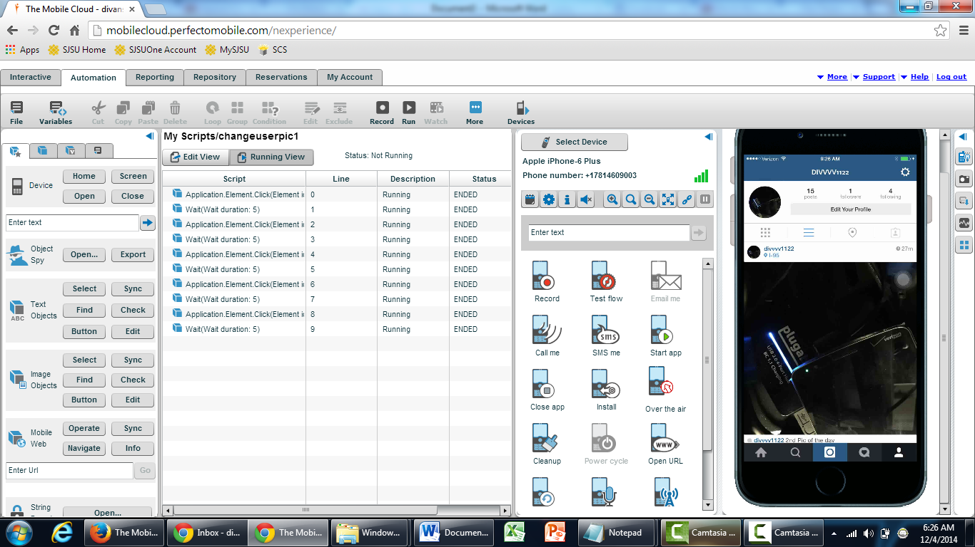

**Edit profile**

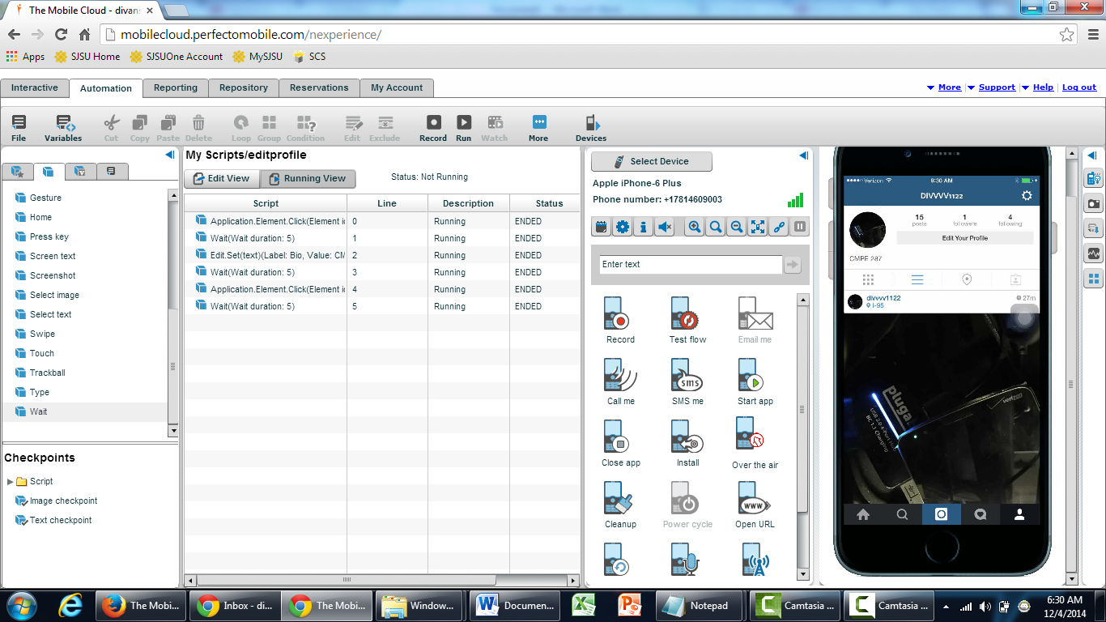

## Automation Summary-

IOS – 14; Android - 13

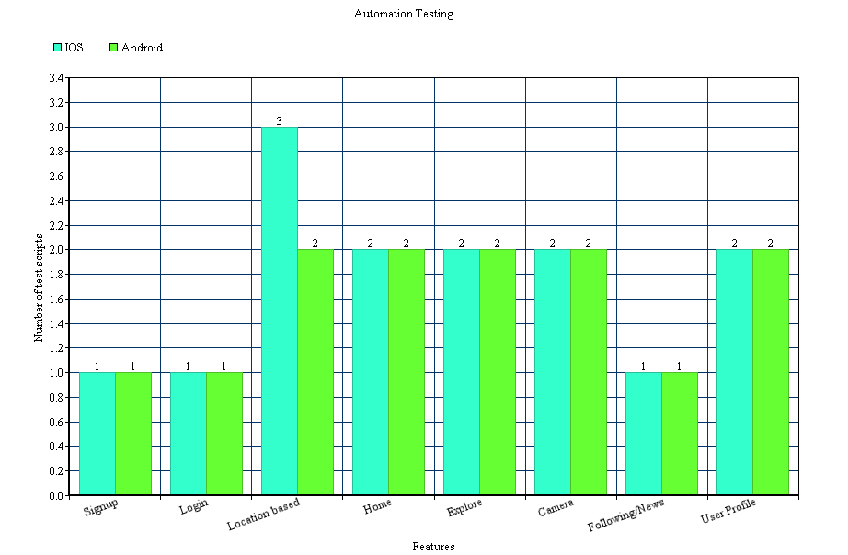

## **Automation test cost and complexity -**

## Automation Test Cost –

This section discusses the cost of testing the application. The testing cost can be categorized in the following below areas -

* Infrastructure cost
* Tool cost
* Human Resource cost

## Infrastructure Cost

‘Instagram’ application can be tested via a physical device – Mobile or on an emulator. We have tested the application using mobile device - Android and IOS smartphones.

The following table illustrates the cost of mobile devices.

|  |  |
| --- | --- |
| **Device** | **Cost** |
| IOS Device | $249-$649 |
| Android Device | $199-$630 |

## Tool Cost

For reporting of all the tests and their related bugs, we used the below two tools –

Neoload and Perfecto Mobile

Elementool is usually free tool.

Perfecto mobile has a trail fre period of 2 hours after that a subscription is required.

## Human Resource Cost

A team of 5 tested the Instagram application –

|  |  |  |  |
| --- | --- | --- | --- |
| **Resource Name** | **Hours (per day)** | **Total no.of days worked** | **Total cost(per resource)** |
| Divanshu Arneja | 5 | 4 (December 1,2,3,4) | $150.00 |
| Shilpa | 5 | 4 (December 1,2,3,4) | $150.00 |
| Saumil Jain | 5 | 4 (December 1,2,3,4) | $50.00 |
| Piyush Seth | 5 | 4 (December 1,2,3,4) | $50.00 |
| Surbhi Rautji | 5 | 4 (December 1,2,3,4) | $50.00 |

## Test results analysis –

|  |  |
| --- | --- |
| **Total Number of Test Scripts Executed** | **27** |
| **Total Number of Test Scripts Passed** | **27** |
| **Total Number of Test Script Failed** | **00** |

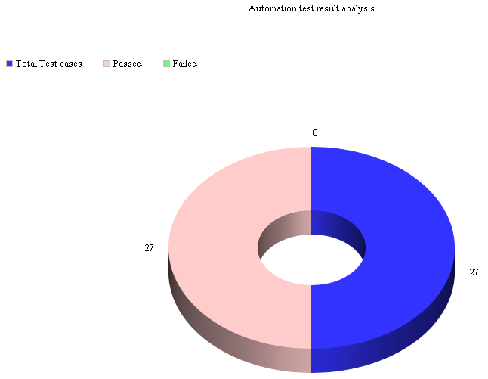

**Manual VS Automation**

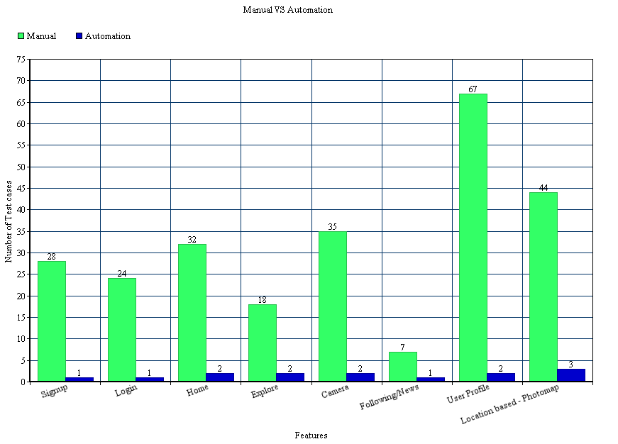

## **Automation test coverage –**



## **Comparison between automated test cost and manual test cost –**

The following diagram shows the description of how the cost involved in the manual testing and automation testing has differed from each other.

**Infra-Structure Cost Comparison:**

|  |  |  |
| --- | --- | --- |
| Testing Type | Gadgets | Cost |
| Manual | Android Device & IOS Device | $1300 |
| Automation | Android Device & IOS Device | $1300 |

**Tool Cost Comparison:**

|  |  |  |
| --- | --- | --- |
| Testing Type | Tools | Cost |
| Manual | Elementool and Bugzilla | $0 |
| Automation | Neoload and Perfectomobile | $0 |

**Human Resource Cost Comparison:**

|  |  |  |
| --- | --- | --- |
| Testing Type | Human Resource | Cost |
| Manual | 5 Team Members | ($150*5) = $750 |
| Automation | 5 Team Members | ($150*2 + $50*3) = $450 |

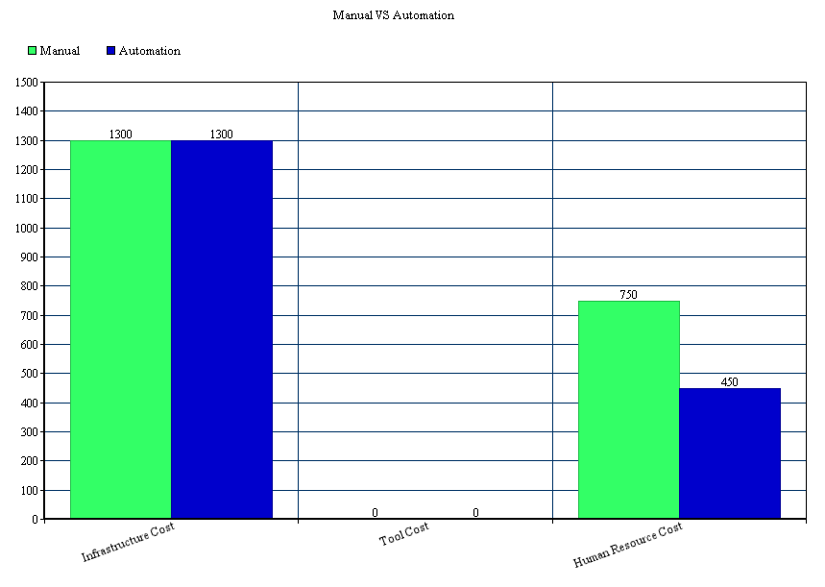

## **Summary -**

In the conclusion, we automated the application for almost all the features. We also provided the best automation test result analysis with respect to all the GUI features in pictorial format.

The tools we used were easy to use.

Automation testing is good choice to perform testing by the developers and testers as it has many advantages as compared to manual testing:

• Efficient Testing

• Good Test Coverage

• Minimum Test Scripts

• Minimum Tools Required

• Minimum Gadgets Required

• Minimum Human Resources Required

## **References**

1. *Gao, J., Tsao, H. S., & Wu, Y. (2003). Testing and quality assurance for component-based software. Artech House.*
2. *Gao, J., Espinoza, R., & He, J. (2005, July). Testing coverage analysis for software component validation. In Computer Software and Applications Conference, 2005. COMPSAC 2005. 29th Annual International (Vol. 1, pp. 463-470). IEEE.*
3. *Gao, J., Espinoza, R., & He, J. (2005, July). Testing coverage analysis for software component validation. In Computer Software and Applications Conference, 2005. COMPSAC 2005. 29th Annual International (Vol. 1, pp. 463-470). IEEE.*
4. *Gao, J.,Bai Xiaoying, Tsai Wei-Tek , and Uehara ,Tadahiro. Mobile Application Testing :A tutorial,* Retrieved on 3rd March 2014 from [*https://sjsu.instructure.com/courses/1070405/files#SP14%3A%20CMPE-287%20Sec%2001%20-%20SW%20Qlty%20Assur%2Fmobile-testing-and-resources%2Fr2gao-v3-IEEE-Computer-Paper.pdf*](https://sjsu.instructure.com/courses/1070405/files#SP14%3A%20CMPE-287%20Sec%2001%20-%20SW%20Qlty%20Assur%2Fmobile-testing-and-resources%2Fr2gao-v3-IEEE-Computer-Paper.pdf)
5. *Project Assignment, Retrieved on 2nd March 2014, from* [*http://www.scribd.com/fullscreen/207060411?access_key=key-1m24bv0klu5zlbw3mqvb&allow_share=false&escape=false&show_recommendations=false&view_mode=scroll*](http://www.scribd.com/fullscreen/207060411?access_key=key-1m24bv0klu5zlbw3mqvb&allow_share=false&escape=false&show_recommendations=false&view_mode=scroll)
6. *Gao, Jerry. "Testing Component-Based Software." Proc. of STARWest, San Jose, USA (1999)*
7. *CmpE 287 slides and class notes*